Production Planning and Execution (PP)

Master Data
Material (Deluxe Touring Bike (black)) | DXTR1013
Material (Deluxe Touring Bike (silver)) | DXTR2013
Material (Deluxe Touring Bike (red)) | DXTR3013

Organizational Units
Company Code (Global Bike Inc.) | US00
Plant (Dallas) | DL00
Storage Location (Finished Goods) | FG00
Storage Location (Semi-finished Goods) | SF00
Storage Location (Raw Materials) | RM00

Employees involved
Jun Lee | Production Supervisor
Hiro Abe | Plant Manager Dallas
Lars Iseler | Production Order Worker
Susanne Castro | Receiving Clerk
Sanjay Datar | Warehouse Employee
Michael Brauer | Shop Floor Worker 4
Jamie Shamblin | Cost Accountant

As directed in the instructions, replace your instructor’s screenshots with your own in each section.

Step 2: Change Routing
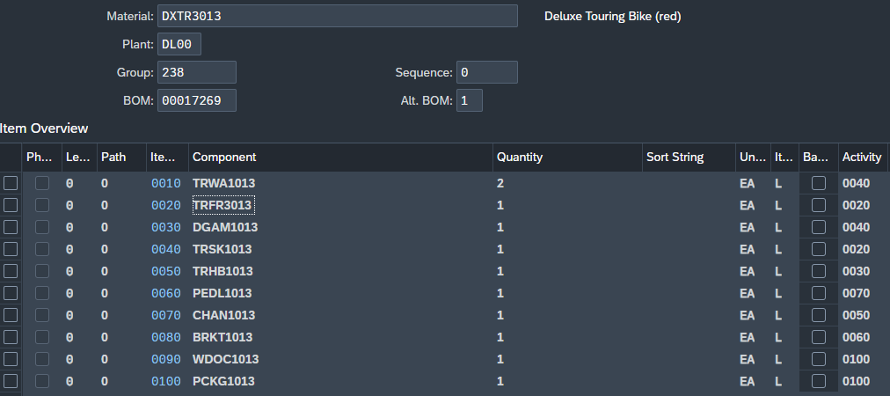


Step 4: Create Sales and Operations Plan (SOP)
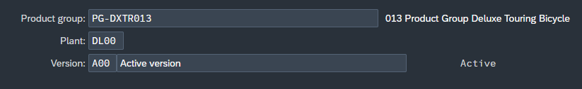

SOP for Sales Only
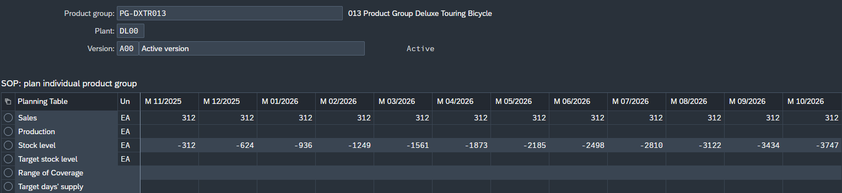

SOP for Sales and Production

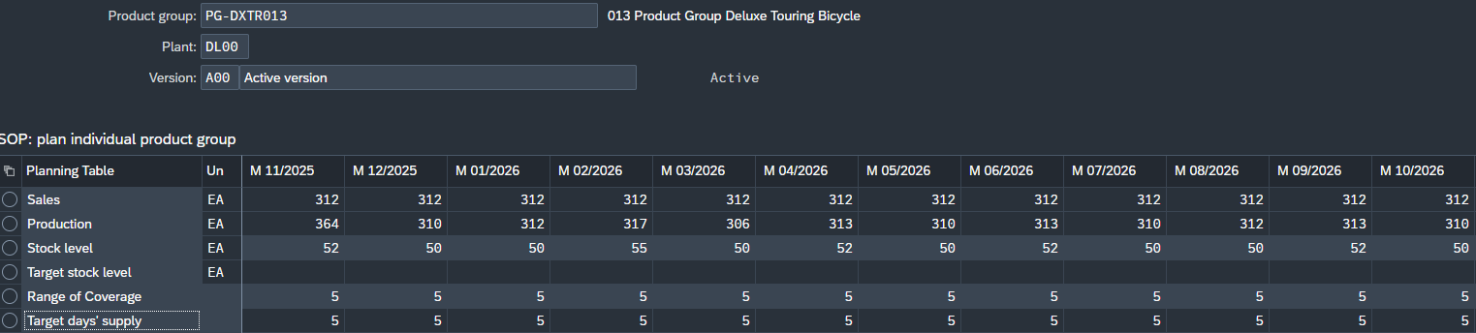


Step 5: Transfer SOP to Demand Management

Planned Independent Requirements for DXTR1### - Deluxe Touring Bike (black)
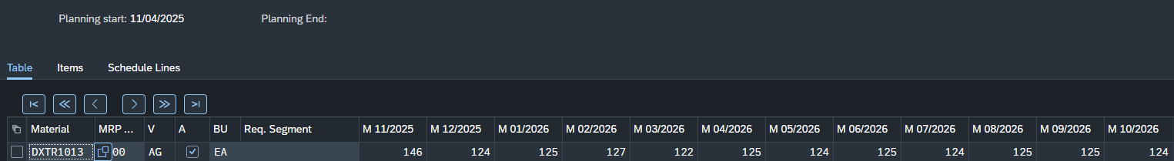

Planned Independent Requirements for DXTR2### - Deluxe Touring Bike (silver)
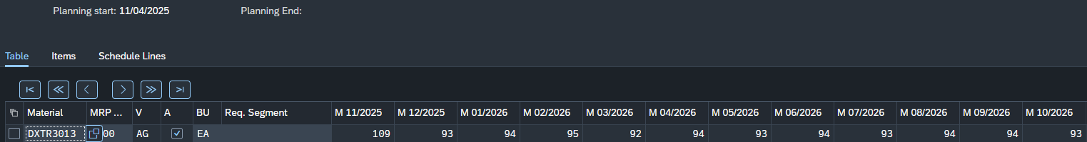

Planned Independent Requirements for DXTR3### - Deluxe Touring Bike (red)
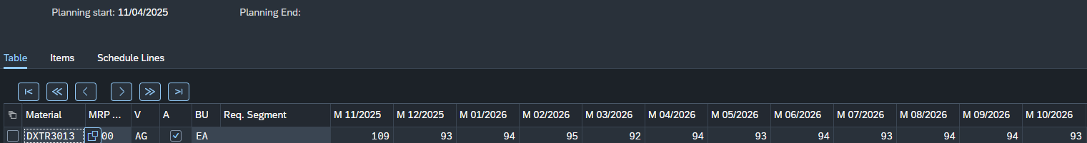

Step 6: Run MPS with MRP

MRP Parameter Settings

MRP Result Overview

MRP Detailed Materials List

Step 7: Review Stock/Requirements List
Period Totals

Individual Rows

Step 8: Convert Planned Order into Production Order

Step 9: Receive Goods in Inventory

Step 10: Issue Goods to Production Order

Step 12: Confirm Production Completion

Step 14: Receive Goods from Production Order

Step 16: Settle Costs of Production Order

